AI for Ops PoC—— Inventory Sizing, Simulation, and Monitoring Blueprint Design v0.1

Understanding Future Business

1.1 Supply Network Structure
The supply network consists of multiple levels of nodes, including suppliers, factories and distribution centers (e.g., CDC, RDC), as shown in Figure 1. For L'Oréal Paris products, raw and packing materials (abbreviated as RPM) are sourced from suppliers, processed in factories to become finished goods (abbreviated as FG), and then stored in central distribution center (CDC). For Lancôme products, FG are imported directly from overseas suppliers and stored in CDC.
For both brands, CDC then distributes product inventory to regional distribution centers (RDC). RDCs receive inventory solely from CDC and never directly from factories or import. RDCs either have order fulfillment capabilities to consumers (to C only), or to business and consumers (to B and to C). Inventories for both business and consumer orders are managed centrally in a unified manner, which ensures that inventory can be utilized across both channels.
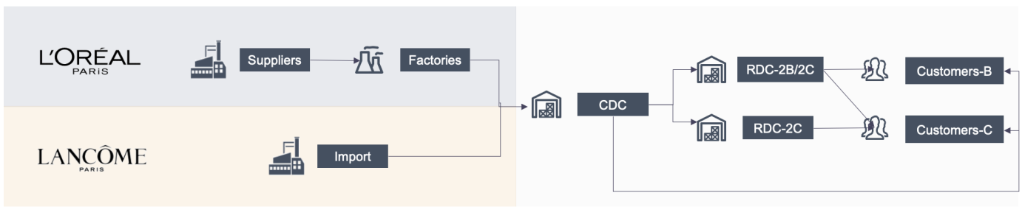
Figure 1. Supply network structure of L'Oréal Paris and Lancôme

As a special case, the Suzhou CDC is responsible for order fulfillment directly in the East region (i.e., East China region) due to its geographical proximity. As the inventory for order fulfillment in the Huadong region is not managed separately from the broader inventory at the CDC, when the CDC's inventory falls short of meeting national demand, the available stock will be distributed among the Huadong region and all RDCs. Therefore, from a business solution standpoint, the CDC does not operate with a "virtual warehouse" concept. Under this understanding, future solutions will involve centralized management of the CDC inventory, with a consolidated inventory sizing results being generated and simulated in later periods of the project.

1.2 Inventory Strategy

1.2.1 Raw and Packing Materials (RPM)
- Inventory Management of RPM for L'Oréal Paris vs. Lancôme: Local Production vs. Imported Finished Goods
For L'Oréal Paris, as products are manufactured locally, it is necessary to account for inventories of raw materials (RM) and packing materials (PM). RPM is not a concern for Lancôme, as all products are imported from Europe or Japan as FG.
- RPM Inventory Management at two nodes: Suppliers and Factories
There are two key nodes where RPM is a major consideration: suppliers and factories. The RPM inventory held by suppliers constitutes a liability for L'Oréal, while inventory maintained at factories are classified as assets of L’Oréal. This distinction requires consideration of different management strategies.
  - At the node of suppliers, L’Oréal informs suppliers of the required inventory levels for each RM and each PM, specifying how many months’ of stock should be maintained, while taking replenishment lead-time into consideration. The remaining decision, including deployment and production ordering are then handled by the suppliers or traders directly.
  - For factories, factory inventory management focuses on ensuring production continuity, accounting for shipment lead-time uncertainties from suppliers. For A-class and Hero-class RPM, inventory is designed to be held at around one month's worth of stock. For PM in Suzhou, as well as B-class and C-class RPM, inventory is structured to be kept at approximately two weeks' worth of stock.
- Inventory Replenishment Strategy: ROP and Q for Stock Management
The specific inventory replenishment method adopts the logic of ROP (reorder point) and Q (order quantity), where ROP ensures that an order is placed in time before running out of stock, and Q determines the size of each order to minimize costs.
- Converting Days of Safety Stock to Units with the concept of Coverage
Two relevant inventory metrics and output: Days of Safety Stock (DOS) and units are converted through a concept of demand coverage.
  - Days of Safety Stock refers to the amount of stock held to account for demand fluctuations and supply uncertainties, expressed in terms of the number of days.
  - Units refers to the actual quantity of stock.
  - Coverage refers to the number of days of demand that the current inventory level can support, in other words, it indicated how many days of demand can be covered by existing stock.

1.2.2 Finished goods (FG)
- FG inventory management nodes: CDC and RDC
Inventory management of finished goods is a critical process for both L'Oréal Paris and Lancôme. There are two key nodes in the supply chain where decisions regarding finished goods inventory are critical: CDC and RDCs.
Currently, inventory management decisions are made on a quarterly basis, and we will be exploring the possibility of shifting to a more frequent decision-making cycle, specifically monthly updates, to determine if it could offer improved results. At the end of this PoC, we aim to evaluate whether a monthly or quarterly decision frequency would be more effective for SKUs or groups of SKUs.
- Inventory Replenishment Strategy: ROP and Q for Stock Management (same as RPM)
The SAP APO inventory replenishment plan is reviewed and adjusted every week to reflect the most current data input, demand fluctuations, production adjustments, etc. The inventory replenishment method for FG follows the same logic of ROP and Q, where the ROP ensures that an order is placed before stock levels fall too low, and the Q determines the optimal order size to minimize overall costs.
- Converting Days of Safety Stock to Units with the concept of Coverage (same as RPM)
The two key inventory metrics for finished goods are Days of Safety Stock (DOS) and units, with conversion between the two being derived using the concept of demand coverage, consistent with the method used for RPM.

1.2.3 Regional distribution centers (RDC)
The inventory replenishment strategy for all RDCs (Regional Distribution Centers) is based on an inventory level for a given number of days (approximately 30 days). The replenishment decision is driven by ROP and Q. In terms of inventory metrics, Days of Safety Stock (DOS) and units are both calculated using the concept of coverage.

1.3 Replenishment Strategy
- Strategy adopted: (ROP, Q)
ROP stands for Re - Order Point. When the inventory level drops to this point, replenishment is triggered. It is obtained by adding Cycle inventory and Safety stock. Among them, Safety stock represents buffer inventory held to account for variability in demand and lead-time, while Cycle inventory represents the demand covered during the period from placing an order to receiving it. Q represents the fixed order quantity each time replenishment is triggered. (See "5. Simulation and Monitoring" part for details)

POC Validation Methods

2.1 POC Analysis Scope

2.1.1 SKU Scope
- Segmentation: It includes both L'Oréal Paris and Lancôme FG. After preprocessing the material codes through substitution and selecting the existing codes in the business data, 269 and 279 valid FG SKUs have been selected respectively. The scope of the segmentation will cover these 269 + 279 = 548 FG SKUs. On the other hand, based on the BOM data, the BOM heads in sales and forecast data are split into individual products. The individual products within the range of these 548 are selected as the scope for consideration, while the individual products that are only sold in BOM sets outside this range will not be taken into account.
- Sizing and Simulation: We will make selections after reaching a consensus on the output results of Segmentation. 50 representative FG SKUs will be selected from the 548 FG SKUs. These 50 FG SKUs and their corresponding RPM SKUs will be within the coverage scope of sizing and simulation.

2.1.2 Network Scope
- Supplier (several)
- Factory
    - 2 Factories (Suzhou and Yichang)
- Distribution Network
  - 1 CDC
  - 18 RDCs (5 for 2B business and 18 for D2C business)

2.1.3 Time Range
- Reference period: Our Analysis with data is in the time range of the past two years, covering the period from January 2023 to November 2024.
- Simulation back-testing period: The simulation back-testing covers the recent six months from May 2024 to November 2024.

2.2 Validation Approach
We framed a step-by-step approach to help validate below key points during PoC phase:
- Is it possible to leverage clustering algorithm i.e. K-Means to segment existing SKUs subject to multiple inventory-related parameters (demand distribution, supply complexity etc.)?
- What are right statistical models (normal distribution, random forest, gradient boosting decision tree etc.) to estimate demand and supply volatilities of these segments respectively?
- In terms of SKU classification (i.e. Hero, A, B and C-Classes), what are the most efficient inventory sizing decision frequency?
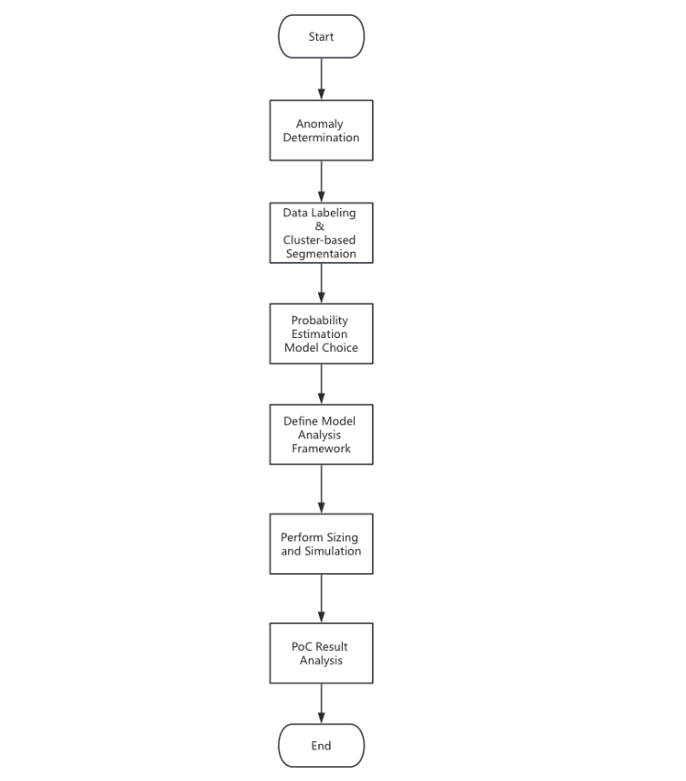
Figure 2. xxx

Below are detailed descriptions of key PoC validation actions/steps:

Anomaly Determination
  - Method:
    - Leverage Cardinal's standard approach to identify FG SKUs with pattern anomalies i.e. insufficient demand data, limited sales period. (See "3. Segmentation" part for details)
  - Output:
    - List of FG SKUs to be excluded in PoC analysis

Data Labeling and Cluster-based Segmentation
  - Method:
    - Leverage data labeling method (e.g. bias label, saturation label) to group and segment FG SKUs
    - Leverage clustering algorithms i.e. K-Means to group and segment FG SKUs subject to multiple inventory-related parameters (i.e. demand distribution)
    - Combine data labeling result and clustering result to frame initial segments for detailed probability estimation analysis
    - Additional Notes: Brand differentiation is naturally a distinctive factor due to differentiated supply modes of L'Oréal Paris and Lancôme. Therefore, the brand dimension is treated as mandatory and is not assessed in this step
  - Output:
    - Initial segments of FG SKUs for detailed Goodness-of-Fit test

Probability Estimation Model Choice
  - Why quantile
    - Normal: If we calculate variances directly, it means we have assumed that the forecast error is normally distributed with zero mean. It can be seen that this method is liable to abnormal distributions and potential systematic errors in forecasting.
    - Quantile: We estimate variances by performing quantile regression on forecast errors and converting quantiles to variances, which handles the above problems. (see section 4.2 for detail)
  - Method:
The effectiveness of the variance estimation is dependent on the accuracy of quantile regression, so we measure the goodness of fit of quantile levels. We use the following loss function for evaluation:
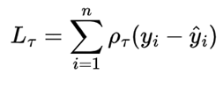
Here, each i corresponds to a sample data for evaluation. is the actual error, is the quantile estimation of the model and 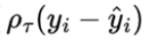 is the check function at quantile level which calculate the loss of model at a single sample point.
During PoC phase, we will perform variance estimation on all initial segments subject to all four methods (Normal, SAA, Quantile Regression, Gradient Boosting Quantile Regression) and find out the best-fit model for each initial segment.
  - Data range:
    - model training: 2023.01 - the month before simulation
    - model evaluation: time range of simulation
  - Output:
    - Best-fit statistical model for each initial segment

Define Model Analysis Framework
  - Description:
    - Jointly define key sizing and simulation analysis inputs with L'Oréal, including model choices, frequency options and result analysis dimension
  - Output:
    - Consensus model choices:
-MEIO-1: For all Lancôme products within PoC analysis scope
-MEIO-3: For all L'Oréal Paris products within PoC analysis scope
    - Decision frequency options for sizing and simulation analyses
-Quarterly
-Monthly
    - Potential Result Analysis Dimensions
-SKU Classification (Hero/A/B/C)

Perform Sizing and Simulation
  - Method:
    - Perform inventory sizing and simulation algorithms (See "4. Inventory Sizing" and "5. Simulation and Monitoring" parts for details)
  - Output:
    - Sizing and Simulation results

PoC Result Analysis
  - Method:
    - Analyze the output of sizing and simulation algorithms based on pre-aligned dimensions
  - Output:
    - Frequency analysis result
-Potential inventory saving and CSL simulation results for each class (Hero/A/B/C)
    - Segmentation result, incorporating below dimensions:
-Brand: L'Oréal Paris and Lancôme
-Clustering and fit result
-Frequency analysis result
    - Overall Inventory optimization result
-Total inventory saving (DOS and relative value)
-Total CSL performance

Segmentation
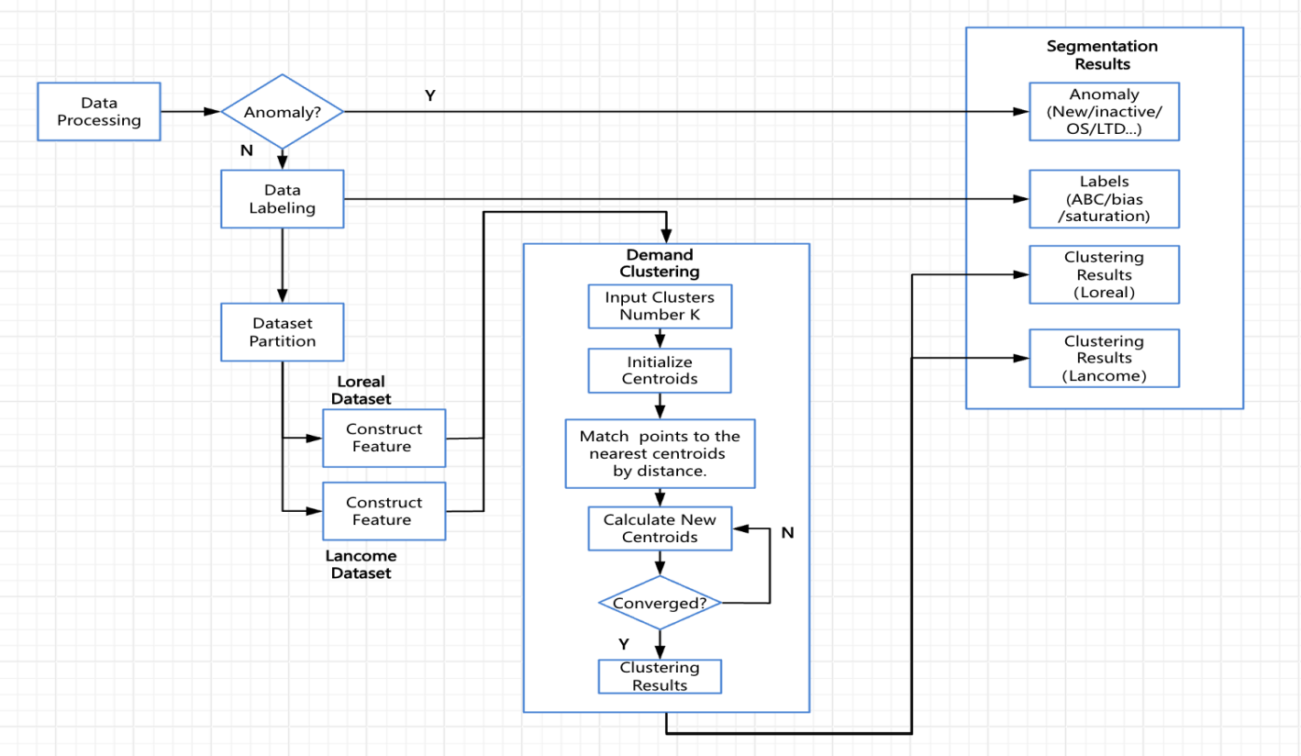
Figure 3. xxx
- Outputs
  - sku_labels: ABC class & saturation & bias segmentation.
  - cluster_results: The clustering results according to the features of demand pattern (seasonality, volatility, forecast accuracy).
Dimensions | Seg Method | Seg Results | Sizing Method
ABC class | Data labeling | Hero/A/B/C | Different lead k (Lead time Tuned Factor）
saturation | Data labeling | high-saturation / low-saturation | High-saturation corresponds to  production lead time error,  while lead time error is 0 for low-saturation.
demand | Clustering Algorithm | cluster 1/2/3...... | Different quantile regression methods in demand volatility estimation test.
bias | Data labeling | underestimated / normal/ overestimated | It is not directly distinguished in the sizing method. However, underestimation/overestimation may lead to higher/lower safety stock results, which should be paid attention to during the result analysis.
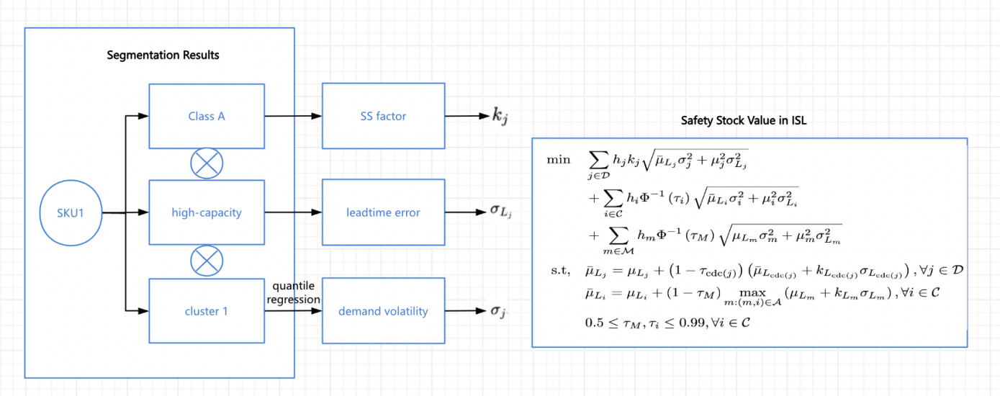

3.1 Data Preprocessing
- Data Input
  - item_data：Master data of products, containing information such as categories.
  - sales_data：Historical monthly sales data.
  - fcst_data：Historical monthly demand forecast data.
  - bom_data：Mapping table of the correspondence between Bom heads and components.
  - substitution_data：Product substitution mapping table.
  - saturation_data: Line saturation and skid saturation for L'Oréal Paris products.
- Data Prepare
  - BOM split: Split the sales volume and forecasts of the Bom head into sub-components and shift the corresponding data of the sub-components one month ahead.
  - Product substitution: Identify the substitution relationships according to the substitution data and the first six digits of the material code and map the products with substitution relationships in the sales volume data, forecast data, and master data.
  - Forecast version: For L'Oréal Paris products, refer to the M-1 forecast, while for Lancôme products, refer to the M-3 forecast.
  - Supplementing continuity for sales volume: In case there is temporal discontinuity in the monthly sales volume, in order to ensure the integrity of features when the algorithm is conducting feature engineering, supplement the points where there is no sales with 0.
  - Filling in forecast volume: For products with a forecast value of 0 in the last three months but sales volume in the last three months greater than 5% of the sales volume in the last year, the forecast value will be filled with the previous non-zero forecast.
- Tag abnormal bias point
  - Calculate forecast bias and tag the abnormal points of bias by SKU, Specifically, we determine the abnormal points of bias by calculating the z-score of the data points. That is to say, it is calculated as the ratio of the monthly bias to the mean of the monthly bias of that SKU, divided by the standard deviation of the monthly bias of that SKU. This statistic is often used to measure the degree to which a data sample deviates from the mean of the data set so as to identify outliers. Here, we label the data points with a z-score greater than 2 (that is, the monthly bias of that SKU is greater than twice the standard deviation of the bias mean of that SKU) as abnormal points.

3.2 Anomaly Determination
Identify new products, inactive products, etc. through historical sales and forecast data, and exclude these SKUs from the scope of algorithms. The specific classification sequence and judgment basis are as follows:
- New: Products whose time since the first sale is no more than 3 months.
- Pulse: Products with the number of months having zero sales within the last 12 months being no less than 9.
- Inactive: Products with a forecast value of 0 in the last three months and sales volume in the last three months less than 5% of the sales volume in the last year. (After Filling in forecast volume.)
- Outlier: Products with the number of months having historical forecasts not exceeding 6.
A total of 169 products have been selected, among which there are 45 new products, 22 pulse products, 78 inactive products and 8 outlier products. In addition, 3 products have been selected through the filter of those with ' OS' in the product description.
The above 172 SKUs identified as anomalies account for 6% of the overall SKUs in terms of sales volume in the past year.

3.3 Data Labeling Segmentation
- ABC class label
It is calculated through the given judgment method. For example, sku sales volume in the previous year ranking in the top 60%/80%/90%/100% are classified as Hero/A/B/C respectively.
- saturation label
For L'Oréal Paris products, calculate the average line saturation and skid saturation for six months, and take the larger value as the final saturation. Products with saturation of less than 70% are marked as low-saturation products, while those with saturation of more than 70% are marked as high-saturation products.
- bias label
Calculate the ratio and percentage of bias without abnormal bias tag by SKU. SKUs with a proportion of months with underestimated forecasts exceeding 70% and an average underestimation exceeding 20% will be identified as having continuously underestimated forecasts. SKUs with a proportion of months with overestimated forecasts exceeding 70% and an average overestimation exceeding 20% will be identified as having continuously overestimated forecasts. The rest will be identified as regular products.

3.4 Cluster-based Segmentation

3.4.1 Feature Engineering
In order to achieve differentiated modeling of subsequent inventory sizing algorithms, the following aspects mainly need to be considered in feature selection and construction during clustering:
Measurability | The features used for clustering should be measurable so that the similarity between samples can be evaluated.
Interpretability | Features should have clear business implications to ensure the interpretability of clustering results.
Dimensions | Clustering should take multi-dimensional information into account, but the number of dimensions should not be too high either, as the distances between data points in high-dimensional space are difficult to interpret.
Relevance | Select features that have a strong connection with inventory management methods and are directly helpful for inventory sizing models.

Based on the above principles combined with the data foundation, it is considered to construct the following features to cluster the products of the two brands, L'Oréal Paris and Lancôme, respectively. These features including seasonality, forecast accuracy, and volatility, mainly describe the sales mode. These features have a direct relationship with the safety stock modeling. Product category, ABC classification, and price are not directly selected as features for clustering, mainly considering the following three aspects: it is difficult to quantitatively evaluate the similarity of product category information, it is not directly related to safety stock modeling, and to avoid having too many dimensions. When evaluating the clustering results, it is considered to focus on analyzing the connections between various categories and the clustering results and try to select products of different categories when choosing the scope for subsequent modeling.
- Seasonality (Seasonality index): average monthly sales/average total monthly sales, the further it deviates from 1, the stronger the seasonality is. For a single product, its maximum seasonality index is regarded as the seasonality indicator of this product, and the month corresponding to the maximum value is regarded as the peak month of this product.
- Forecast accuracy (excluding the peak month): 1 - difference between the monthly demand and sales volume / the total sales
- Volatility (Coefficient of Variation, excluding the peak month): sales std / sales mean.

3.4.2 Modeling of Clustering
There are many classic algorithms for clustering, and K-means is one of the commonly used ones. Its fundamental principle is as follows: when presented with a set of given data points, the algorithm aims to partition all these data points into K distinct clusters. The objective is to minimize the sum of the squared distances between each individual data point and the center of the particular cluster to which it is assigned. To put it simply, in this process, the algorithm requires the number of categories (K) as an input parameter. Subsequently, it determines and outputs the classification of each sample. The ultimate goal is to make the samples within each category as close as possible to one another in terms of their feature values.
Regarding the determination of the number of categories, from a data - driven perspective, we can introduce certain data indicators to quantitatively assess and characterize the quality of the clustering results. Through this approach, we are able to identify the specific number of categories that corresponds to the optimal clustering effect. For instance, the silhouette coefficient is a useful metric. It can be employed to precisely describe the cohesion (how closely grouped the samples within a cluster are) and separation (how distinct and well - separated different clusters are from one another) of the clustering results. For a more detailed explanation and illustration, please refer to the description in the " 3.4.3 Result Evaluation" chapter.
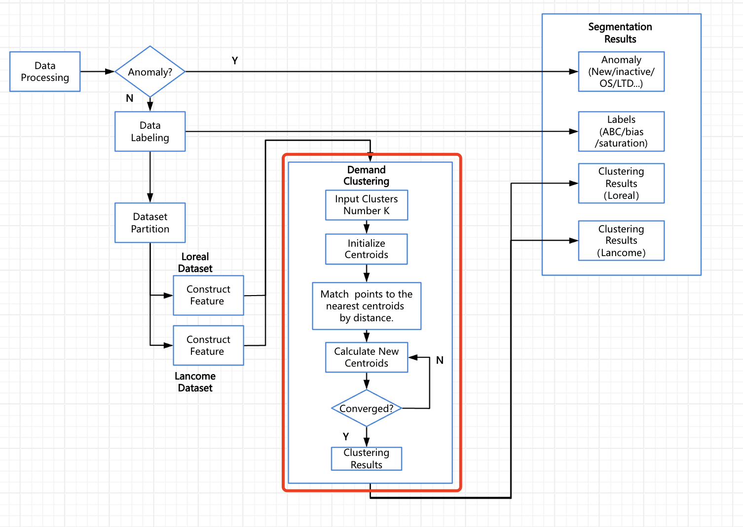
Figure 5. xxx

3.4.3 Result Evaluation

3.4.3.1 Silhouette Coefficient
The silhouette coefficient is an indicator used to measure the quality of clustering results. It combines the cohesion and separation of clustering. The value range of the silhouette coefficient is between -1 and 1. A higher value indicates a better clustering effect, while a lower value indicates a poorer clustering effect. The silhouette coefficient of the entire data set is the average of the silhouette coefficients of all samples.
The calculation of the silhouette coefficient is based on the following two concepts:
- Cohesion: It measures the closeness among samples within the same cluster. For each sample, calculate the average distance between it and all other samples within the same cluster. The smaller this value is, the closer the sample is to other samples within the same cluster, indicating higher cohesion.
- Separation: It measures the closeness between a sample and its nearest cluster (that is, the cluster to which the sample does not belong). For each sample, calculate the average distance between it and all samples in its nearest cluster, and then select the smallest distance as the separation. The larger this value is, the more separated the sample is from its nearest cluster, indicating higher separation.

The silhouette coefficient graph for L'Oréal Paris clustering is shown below. It is found that the best result is achieved when dividing into three categories.
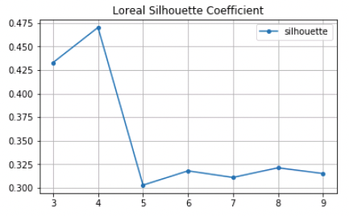
Figure 6. xxx

The silhouette coefficient graph for Lancôme clustering is shown below. It is found that the best result is achieved when dividing into four categories.
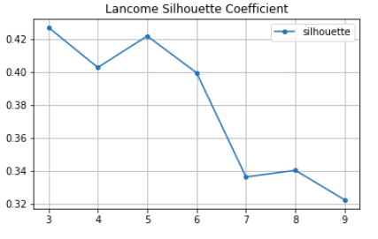
Figure 7. xxx

3.4.3.2 Result Analysis
L'Oréal Paris
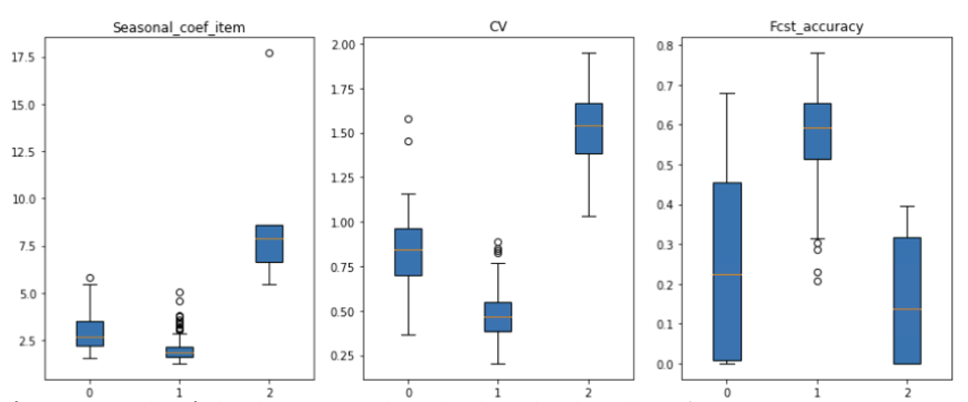
Figure 8. xxx
Lancôme
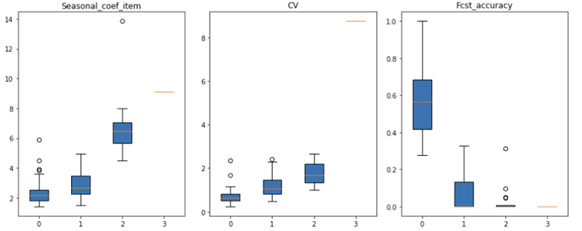
Figure 9. xxx
LRL_0 (promotion),70 in number, high seasonality, high volatility, low forecast accuracy
LRL_1 (normal),190 in number, low seasonality, low volatility, high forecast accuracy
LRL_2 (special promotion),6 in number, very high seasonality, very high volatility, very low forecast accuracy

LAN_0 (normal),79 in number, low seasonality, low volatility, high forecast accuracy
LAN_1 (promotion),92 in number, high seasonality, high volatility, low forecast accuracy
LAN_2 (special promotion),18 in number, very high seasonality, very high volatility, very low forecast accuracy
LAN_3,1 in number, the volatility is abnormally high.

3.4.3.3 Analysis by Category
- L'Oréal Paris
Category | numbers | numbers ratio
Hair Care | 93 | 35%
Face Care | 70 | 26%
Hair Color | 48 | 18%
Face Care for Men | 25 | 8%
Face Cleansing | 16 | 6%
Face Cleansing for Men | 15 | 6%
Body Care | 2 | 1%
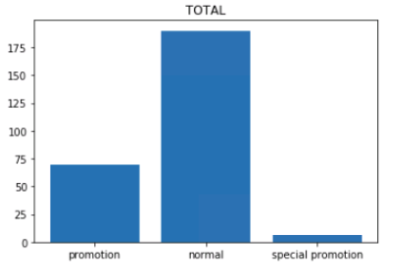
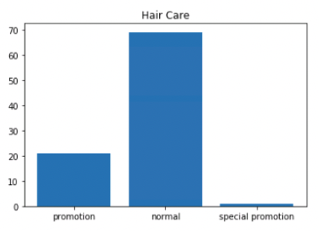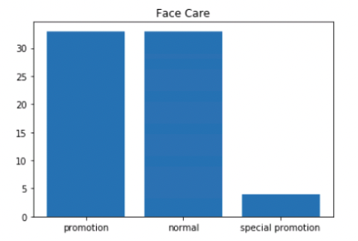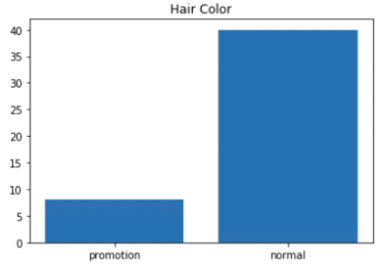
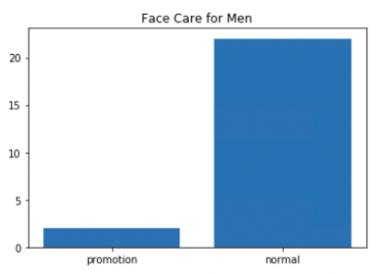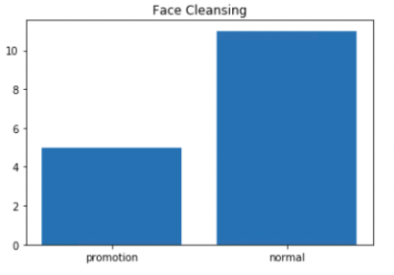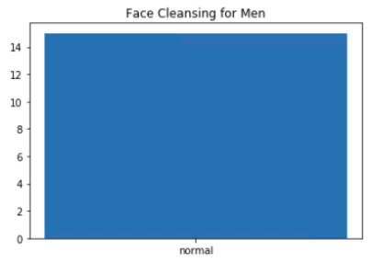
According to the distribution chart by category dimension, it can be seen that:
•Hair Color, Face Care for Men, and Face Cleaning for Men tend to fall into the normal category.
•Face Care has a relatively high proportion of the promotion category.
- Lancôme
Category | numbers | numbers ratio
Lip Makeup | 87 | 31%
Face Care | 80 | 29%
Face Makeup | 52 | 19%
Women Fragrance | 31 | 11%
Face Cleansing | 20 | 7%
Eye Makeup | 7 | 3%
Body Care | 1 | 0%
Instrumental Cosmetic | 1 | 0%
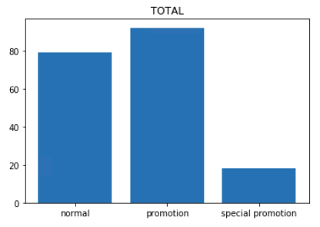
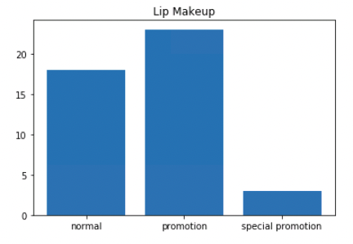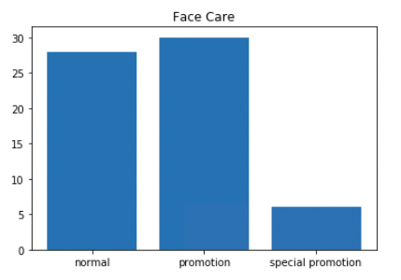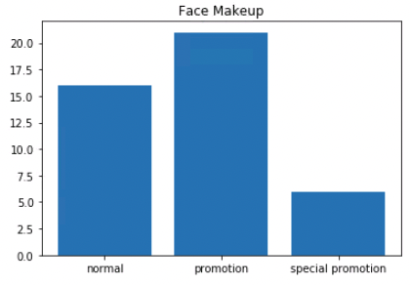
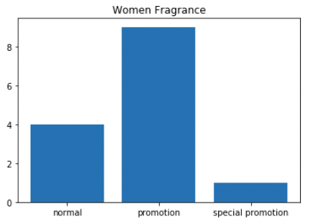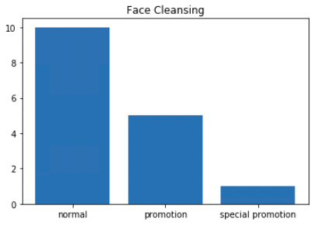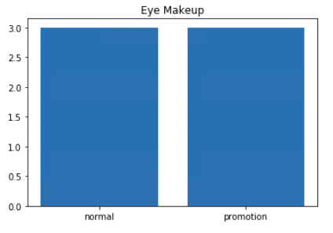
According to the distribution chart by category dimension, it can be seen that:
•Face Cleaning tends to fall into the normal category.
•Face Makeup, Face Care and Lip Makeup all have a relatively high proportion of the promotion category.

3.5 SKUs Selection
When considering how to select around 50 representative SKUs as the scope for subsequent algorithm verification, the following perspectives can be mainly referred to:
Segmentation results | The selected SKUs should cover various segments in different dimensions and try to maintain a balanced number of SKUs in every segments.
Data integrity | Give priority to SKUs with complete data. SKUs lacking forecasts or with a short sales history will not be considered.
Category diversity | After the selection, the proportion of each category among the selected SKUs should be close to the overall category proportion to ensure category diversity.
Sales volume magnitude | Sort the SKUs according to historical sales volume from largest to smallest and give priority to those with a larger sales volume magnitude.

Inventory Sizing
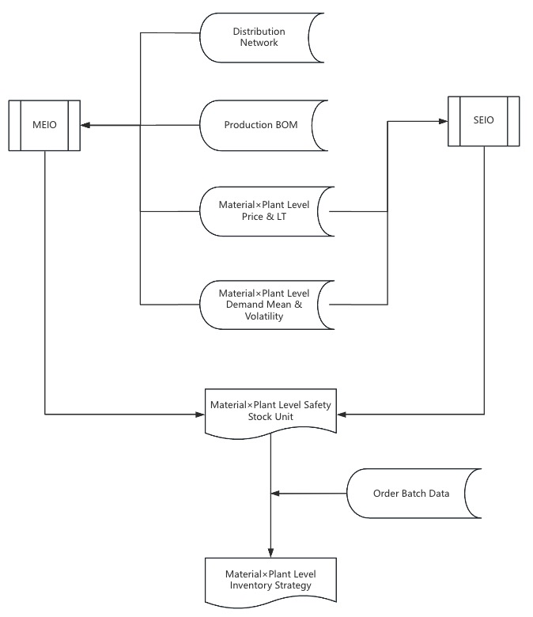
Figure 12. xxx

4.1 Description of ISL Model Theory
ISL model assumes that each node in the network has an expected service level ​$τ_{j}$. When the inventory of the upstream nodes of a node is sufficient, its demand can be satisfied immediately. However, when the inventory of upstream nodes is insufficient, the delivery of its demand will be delayed. The actual replenishment time of a node is equal to the response time of its upstream nodes to its demand plus the node's own lead-time.
The service level of a node may affect the actual replenishment time of all its downstream nodes. Similarly, the actual replenishment time of a node is affected by the service levels of all its upstream nodes. Therefore, it is very difficult to accurately depict the probability distribution of the actual replenishment time. In addition, in the inventory network, when a node is out of stock, it may cause the delivery delay of multiple downstream nodes. Therefore, some approximations and simplifications need to be made during the depiction process. The following is an approximate modeling method.
Assume that each node has at most one upstream node out of stock in each period. And assume that the service time of a stockout node is equal to the replenishment time of that node, that is, the impact of stockout can be traced back at most one level upstream. Thus, the expected replenishment time of node j is expressed as a formula with its upstream node i:
$${\overline{μ}}_{L_{j}}= μ_{L_{j}}+(1−τ_{i})μ_{L_{i}}$$
$Φ^{−1}(τ_{j})\sqrt{{\overline{μ}}_{L_{j}}{σ_{j}}^{2}+μ_{j}^{2}σ_{L_{j}}^{2}}$ is the safety inventory formula of node j. The larger the service level $τ_{j}$​ is, the more safety inventory node j holds. But at the same time, the probability of non-stockout is also higher, which makes the actual replenishment time of downstream nodes shorter, so that downstream nodes can hold less safety inventory.
By depicting the relationship between the actual replenishment time and the service level of upstream nodes, the model links the service levels of all nodes with the inventory levels of the entire network. Then, taking the service levels of all nodes as decision variables, the model minimizes the total safety inventory cost of the network.
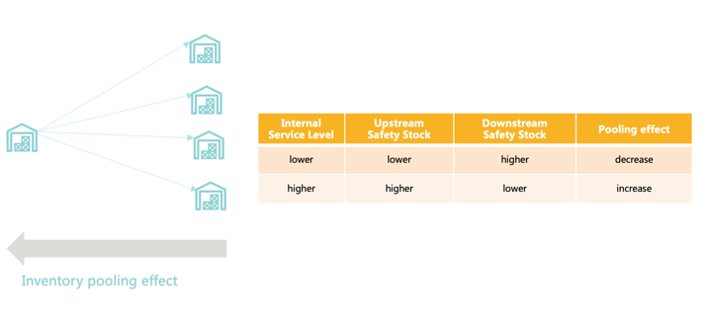
In summary, the ISL model adjusts the safety stock levels of upstream and downstream nodes by regulating the variable Internal Service Level. This enables a trade-off between the magnitude of the pooling effect resulting from the differences in the overall demand volatility between upstream and downstream, and the amount of downstream inventory corresponding to the expected replenishment time.

4.2 Inventory sizing module design

Scenario 1: Lancôme
1. Optimized supply chain illustration
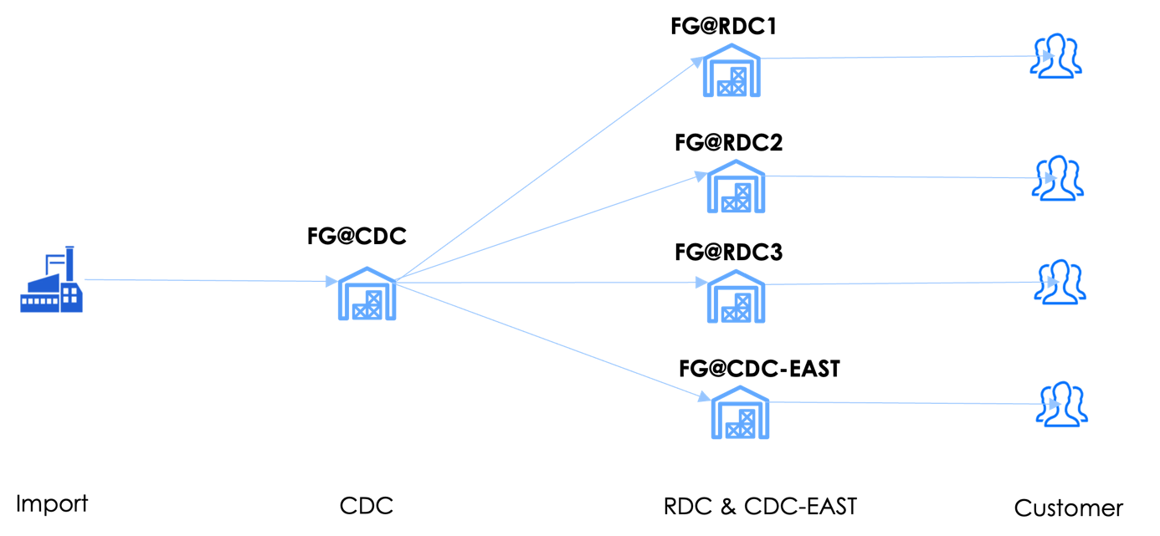
Figure 15. xxx
2. MEIO Model Design
2.1 Basic Model
- Input
Network (Delivery) |  | Material × Plant Level Property
All Optimized Nodes | $$N$$ | LT mean | $$μ_{L_{j}},j∈N$$ |  |  | Demand mean | $$μ_{j},j∈N$$
FG × DC Level External Nodes  (RDC + CDC-EAST) | $$D$$ | LT std. error | $$σ_{L_{j}},j∈N$$ |  |  | Demand std. error | $$σ_{j},j∈N$$
FG × Nation Level Node | cdc | Holding price |  |  |  | $$h_{j},j∈N$$
 |  | Safety stock factor |  |  |  | $$k_{j},j∈D$$
 |  | CDC LT delay factor |  |  |  | $$k_{L_{cdc}}$$
Others
Quantile function of standard normal distribution |  |  |  |  |  |  | $$Φ^{−1}\left(⋅\right)$$
- Decision Variable: Customer Service Level
Material |  | Input |  |  | Decision Variable
FG × RDC |  | $$k_{j},j∈D$$
FG × CDC |  |  |  |  | $τ_{cdc}$
FG × RDC |  |  |  |  | ${\overline{μ}}_{L_{j}}$: the actual replenishment time determined by its upstream CDC  (See Constraint 1 in details)
- ISL based Optimization Model
min j∈D​ℎjkjμLjσj2+μj2σLj2+ℎcdcΦ−1τcdcμLcdcσcdc2+μcdc2σLcdc2 |  |  |  | Objective: Minimize the total safety stock cost across the supply chain.
$${\overset{‾}{μ}}_{L_{j}}=μ_{L_{j}}+\left(1−τ_{\text{cdc}}\right)\left({\overset{‾}{μ}}_{L_{\text{cdc}}}+k_{L_{\text{cdc}}}σ_{L_{\text{cdc}}}\right),∀j∈D$$ |  |  |  | Constraint 1: The actual replenishment time of FG × RDC equals its LT plus the waiting time of its upstream CDC.
$$0.5≤τ_{\text{cdc}}≤0.98$$ |  |  |  | Constraint 2: The ISL value must fall within a specified range.
$$k_{j}\sqrt{{\overset{‾}{μ}}_{L_{j}}σ_{j}^{2}+μ_{j}^{2}σ_{L_{j}}^{2}}$$ |  |  |  | Explanation 1: The safety stock quantity at FG × RDC. Here, the actual replenishment time of FG × RDC is ${\overset{‾}{μ}}_{L_{j}}=μ_{L_{j}}+\left(1−τ_{\text{cdc}}\right)\left({\overset{‾}{μ}}_{L_{\text{cdc}}}+k_{L_{\text{cdc}}}σ_{L_{\text{cdc}}}\right)$ where the LT volatility at CDC is also factored in.
$$Φ^{−1}\left(τ_{\text{cdc}}\right)\sqrt{μ_{L_{\text{cdc}}}σ_{\text{cdc}}^{2}+μ_{\text{cdc}}^{2}σ_{L_{\text{cdc}}}^{2}}$$ |  |  |  | Explanation 2: The safety stock quantity at FG × CDC.
2.2 Post-process of CDC-EAST and CDC
- Step 1: Calculate CDC-EAST safety stock quantity = Adjustable SEIO safety stock quantity where
- Service level: Based on the FG's ABC class
- Actual replenishment lead time = CDC's local lead time
- Step 2: Calculate CDC safety stock quantity = CDC-EAST demand volatility proportion × CDC safety stock quantity from ISL optimization where the proportion = CDC-EAST demand volatility / Sum of demand volatility (all RDCs + CDC-EAST)
- SEIO Model Design
For each FG × DC level node, SEIO calculates the safety stock quantity based on its demand mean, demand standard error, LT mean, and LT std. error. The safety stock factor is based on the ABC classification of the relevant FG.
$$SS_{j}=k_{j}\sqrt{μ_{L_{j}}σ_{j}^{2}+μ_{j}^{2}σ_{L_{j}}^{2}},∀j∈N$$

Scenario 2: L'Oreal Paris & RM Crisis
1. Optimized supply chain illustration
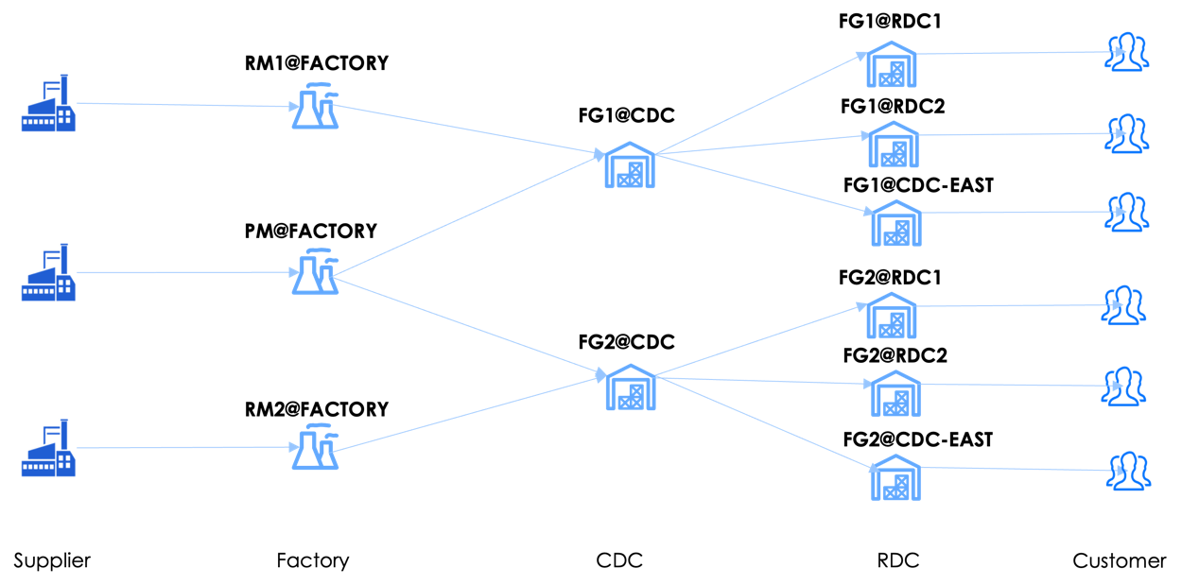
Figure 15. xxx
2. MEIO Model Design
2.1 Basic Optimization Model
- Input
Network (BOM + Delivery) |  |  | Material × Plant Level Property
All Optimized Nodes | $$N$$ |  | LT mean | $$μ_{L_{j}},j∈N$$ |  | Demand mean | $$μ_{j},j∈N$$
RPM × Factory Level Nodes | $$ℳ$$ |  | LT std. error | $$σ_{L_{j}},j∈N$$ |  | Demand std. error | $$σ_{j},j∈N$$
FG × Nation Level Nodes | $$C$$ |  | Holding price |  |  | $$h_{j},j∈N$$
FG × DC Level External Nodes  (RDC + CDC-EAST) | $$D$$ |  | Safety stock factor |  |  | $$k_{j},j∈D$$
Inventory Flows | $$A$$ |  | LT delay factor |  |  | $$k_{L_{m}},k_{L_{i}},m∈ℳ,i∈C$$
Direct CDC node of given RDC node | $$cdc\left(⋅\right)$$
Others
Quantile function of standard normal distribution (given service level input) |  |  |  |  |  |  | $$Φ^{−1}\left(⋅\right)$$
RM Constraint
RMs with constraint | $$ℛ$$ |  | Safety stock quantity constraint for constrained RM |  |  | $$I_{m}=4×μ_{m},m∈ℛ$$
- Decision Variable: Customer Service Level
Material |  | Input |  |  | Decision Variable
FG × RDC |  | $$k_{j},j∈D$$
FG × CDC |  |  |  |  | $$τ_{i },i∈C$$
RPM × Factory |  |  |  |  | $τ_{M }$: to ensure RPM completeness, the RPMs share one internal service level.
FG × CDC |  |  |  |  | ${\overline{μ}}_{L_{i}}$: the actual replenishment time determined by its upstream RPMs  (See Constraint 1 in details)
FG × RDC |  |  |  |  | ${\overline{μ}}_{L_{j}}$: the actual replenishment time determined by its upstream RPMs and direct CDC  (See Constraint 2 in details)
- ISL based Optimization Model
min j∈D​ℎjkjμLjσj2+μj2σLj2+i∈C​ℎiΦ−1τiμLiσi2+μi2σLi2+m∈ℳ​ℎmΦ−1τMμLmσm2+μm2σLm2 |  |  |  | Objective: Minimize the total safety stock cost across the supply chain.
$${\overset{‾}{μ}}_{L_{i}}=μ_{L_{i}}+\left(1−τ_{M}\right)\max_{m:\left(m,i\right)∈A}\left(μ_{L_{m}}+k_{L_{m}}σ_{L_{m}}\right),∀i∈C$$ |  |  |  | Constraint 1: The actual replenishment time of FG ×CDC equals its local LT plus the maximum waiting time of its upstream RPMs.
$${\overset{‾}{μ}}_{L_{j}}=μ_{L_{j}}+\left(1−τ_{\text{cdc}\left(j\right)}\right)\left({\overset{‾}{μ}}_{L_{\text{cdc}\left(j\right)}}+k_{L_{\text{cdc}\left(j\right)}}σ_{L_{\text{cdc}\left(j\right)}}\right),∀j∈D$$ |  |  |  | Constraint 2: The actual replenishment time of FG × RDC equals its LT plus the maximum waiting time of its upstream CDC.
$$Φ^{−1}\left(τ_{M}\right)\sqrt{μ_{L_{m}}σ_{m}^{2}+μ_{m}^{2}σ_{L_{m}}^{2}}≤I_{m},∀m∈ℛ$$ |  |  |  | Constraint 3: Ensure safety stock quantity does not exceed the one-month RM inventory constraint.
$$0.5≤τ_{M},τ_{i}≤0.98,∀i∈C$$ |  |  |  | Constraint 4: The ISL value must fall within a specified range.
$$k_{j}\sqrt{{\overset{‾}{μ}}_{L_{j}}σ_{j}^{2}+μ_{j}^{2}σ_{L_{j}}^{2}}$$ |  |  |  | Explanation 1: The safety stock quantity at FG × RDC. Here, the actual replenishment time of FG × RDC is ${\overset{‾}{μ}}_{L_{j}}=μ_{L_{j}}+\left(1−τ_{\text{cdc}\left(j\right)}\right)\left({\overset{‾}{μ}}_{L_{\text{cdc}\left(j\right)}}+k_{L_{\text{cdc}\left(j\right)}}σ_{L_{\text{cdc}\left(j\right)}}\right)$ where the LT volatility at RPMs and CDC is also factored in.
$$Φ^{−1}\left(τ_{i}\right)\sqrt{{\overset{‾}{μ}}_{L_{i}}σ_{i}^{2}+μ_{i}^{2}σ_{L_{i}}^{2}}$$ |  |  |  | Explanation 2: The safety stock quantity at FG × CDC. Here, the actual replenishment time of FG × RDC is ${\overset{‾}{μ}}_{L_{i}}=μ_{L_{i}}+\left(1−τ_{M}\right)\max_{m:\left(m,i\right)∈A}\left(μ_{L_{m}}+k_{L_{m}}σ_{L_{m}}\right)$ where the LT volatility at RPMs is also factored in.
$$Φ^{−1}\left(τ_{M}\right)\sqrt{μ_{L_{m}}σ_{m}^{2}+μ_{m}^{2}σ_{L_{m}}^{2}}$$ |  |  |  | Explanation 3:  The safety stock quantity at RPM × Factory.
  - Post-process of CDC-EAST and CDC
- Step 1: Calculate CDC-EAST safety stock quantity = Adjustable SEIO safety stock quantity where
- Service level: Based on the FG's ABC class
- Actual replenishment lead time = CDC's actual replenishment lead time (local lead time + max waiting time of RPMs)
- Step 2 (Consistent with "4.2.1 Scenario 1: Lancôme" part)
- SEIO Model Design
For each Material × Plant level node, SEIO calculates the safety stock quantity based on its demand mean, demand standard error, lead time mean, and lead time standard error. The safety stock factor is determined as follows:
- FG × DC: Based on the ABC classification of the relevant FG
- RPM × Factory: Set to 98% as default
$$SS_{j}=k_{j}\sqrt{μ_{L_{j}}σ_{j}^{2}+μ_{j}^{2}σ_{L_{j}}^{2}},∀j∈N$$

4.2.3 Scenario 3: L'Oreal Paris
Except the RM crisis constraints, the process of MEIO and SEIO follow the “4.2.2 Scenario 2: L'Oreal Paris & RM Crisis”.

4.3 Data structure and processing

4.3.1 Optimization network processing
For Scenario 1, the network utilizes an FG × CDC - FG × RDC delivery structure. We maintain a CDC: RDC shipment ratio of 1:1.
For Scenario 2 and 3, the network combines RPM × Factory - FG × CDC production BOM and the FG × CDC - FG × RDC delivery structure. The delivery network remains consistent with Scenario 1. For the production BOM structure, we decompose the raw BOM network into multiple sub-networks by removing some RMs and secondary PMs through the following steps:
Step 1: Exclude 2 PMs not found in master data & Select RM with “Global allocation” and “Others” labels
Step 2: Exclude Secondary PMs (non-mask FG)
Step 3: Exclude RMs with average cost consumption below 1% per FG
Step 4: Exclude RMs shared across 'L9 Function Name' FG hierarchy
 | # FG | # RM | # PM | # Network
Step 1 | 238 | 504 | 706 | 1
Step 2 | 238 | 504 | 287 | 1
Step 3 | 238 | 207 | 287 | 3 | # Max RPM+FG: 726  # Min RPM+FG: 3
Step 4 | 238 | 104 | 287 | 78 | # Max RPM+FG: 81  # Min RPM+FG: 2
# Avg FG per network: 3
# Avg RPM per network: 5
For the RPMs contained in the decomposed sub-networks with relevant FGs, we construct production-delivery networks as each optimization network for safety stock optimization. For the removed RPMs, we calculate their safety stock quantity through SEIO directly.

4.3.2 Key inventory volatility calculation

4.3.2.1 Summary of Parameters
- Factory
$$Φ^{−1}\left(τ_{M }\right)\sqrt{μ_{L_{m}}σ_{m}^{2}+μ_{m}^{2}σ_{L_{m}}^{2}}$$
parameter_definition | parameter_notion | data source & calculation
holding price | $$h_{m},m∈ℳ$$ | Direct Input of LOREAL
ISL | $$τ_{M }$$ | Final Output：Optimizing Variable  To ensure the RPM completeness, the RPMs share one value
safety factor | $$Φ^{−1}\left(τ_{m }\right),m∈ℳ$$ | Map the output ISL to the normal quantile function
LT factor | $$k_{L_{m}},m∈ℳ$$ | Direct Input: LT delay factor (<=1 as default)
Demand mean | $$μ_{m},m∈ℳ$$ | Calculation of BOM quantity & Demand mean of FG & Production LT-offset.  BOM quantity: Direct Input of LOREAL Demand mean of FG: Direct data(future fcst data)  Production LT-offset：Assumption
Demand error | $$σ_{m},m∈ℳ$$
  Calculation of BOM quantity & Demand error of FG & Production LT-offset:
  BOM quantity: Direct Input of LOREAL Demand mean of FG: FG past sales & fcst data
  Production LT-offset：Assumption
LT mean | $$μ_{L_{m}},m∈ℳ$$ | Direct Input of LOREAL  Assumption: Take the supplier import LT value
LT error | $$σ_{L_{m}},m∈ℳ$$ | Calculation of RM/PM based on security scores.
- CDC
$$Φ^{−1}\left(τ_{i }\right)\sqrt{{\overline{μ}}_{L_{i}}σ_{i}^{2}+μ_{i}^{2}σ_{L_{i}}^{2}}$$
$${\overline{μ}}_{L_{i}}=μ_{L_{i}}+\left(1−τ_{M}\right)\max_{m:\left(m,i\right)∈A}\left(μ_{L_{m}}+k_{L_{m}}σ_{L_{m}}\right)$$
parameter_definition | parameter_notion | data source & calculation
holding price | $$h_{i},i∈C$$ | Direct Input of LOREAL
ISL | $$τ_{i },i∈C$$ | Final Output：Optimizing Variable
safety factor | $$Φ^{−1}\left(τ_{i }\right),i∈C$$ | Map the output ISL to the normal quantile function
LT factor | $$k_{L_{i}},i∈C$$ | Direct Input: LT delay factor (<=1 as default)
Demand mean | $$μ_{i},i∈C$$ | future fcst data  Assumption:  1. use latest fcst data up to planning point  2. equally split monthly fcst data into weeks
Demand error | $$σ_{i},i∈C$$ | Calculation of past sales & fcst data;  Assumption:  1. fcst data version: loreal M-1, lancome M-3  2. equally split monthly fcst data into weeks  Steps:  1. quantile regression on [sales-fcst]  2. transform to sigma
LT mean | $$μ_{L_{i}},i∈C$$ | Calculation of Production LT & Quality LT & Planning cycle  Production & Quality LT: Assumption(1week)  Planning cycle: Assumption(1week)
LT error | $$σ_{L_{i}},i∈C$$ | Calculation of Production LT & Quality LT  Production LT: historical saturation data + Empirical estimation  Quality LT: historical actual Quality export data
- RDC
$$k_{j}\sqrt{{\overline{μ}}_{L_{j}}σ_{j}^{2}+μ_{j}^{2}σ_{L_{j}}^{2}}$$
$${\overline{μ}}_{L_{j}}=μ_{L_{j}}+\left(1−τ_{cdc\left(j\right)}\right)\left({\overline{μ}}_{L_{cdc\left(j\right)}}+k_{L_{cdc\left(j\right)}}σ_{L_{cdc\left(j\right)}}\right)$$
$${\overline{μ}}_{L_{cdc\left(j\right)}}=μ_{L_{cdc\left(j\right)}}+\left(1−τ_{M}\right)\max_{m:\left(m,cdc(j)\right)∈A}\left(μ_{L_{m}}+k_{L_{m}}σ_{L_{m}}\right)$$
parameter_definition | parameter_notion | data source & calculation
holding price | $$h_{j},j∈RDCs \& CDC−EAST$$ | Direct Input of LOREAL: 1.05 rate for RDCs (except the CDC-EAST)
safety factor | $k_{j}$, $j∈RDCs \& CDC−EAST$ | Direct Input of LOREAL: service levels based on ABC class
Demand mean | $$μ_{j},j∈RDCs \& CDC−EAST$$ | future fcst data (rdc*week)  Assumption: use latest fcst data up to planning point
Demand error | $$σ_{j},j∈RDCs \& CDC−EAST$$ | Calculation of past sales & fcst data  Assumption:  fcst data source:  1. CDC-EAST: split national fcst data by history sales ratio  2. other RDCs: weekly short-term deployment fcst  Steps:  1. quantile regression on [sales-fcst]  2. transform to sigma
LT mean |  | Calculation of Replenishment LT & Planning cycle  Planning cycle: 1 week  Assumption: LT mean at CDC-EAST(dummy) is set to 0
  $$μ_{L_{j}},j∈RDCs \& CDC−EAST$$
LT error |  | Default as 0
  $$σ_{L_{j}} ,j∈RDCs \& CDC−EAST$$

4.3.2.2 Demand volatility factor
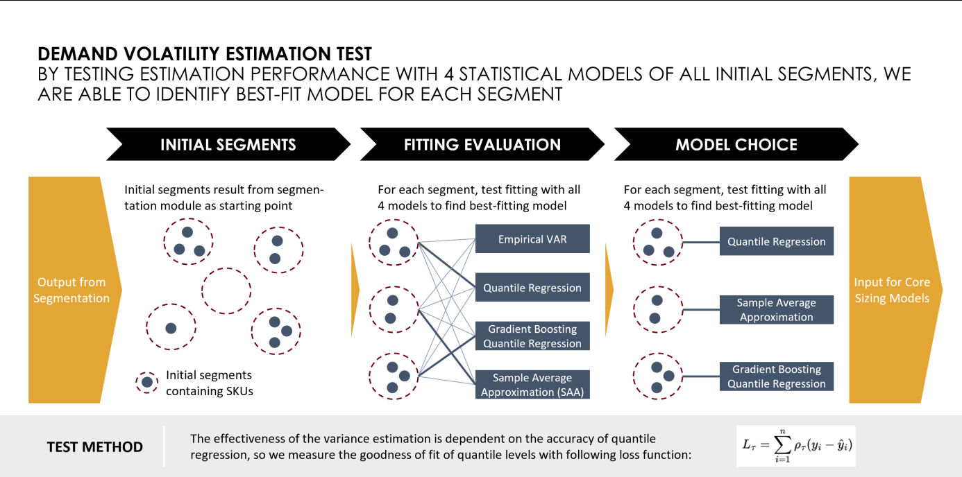
Figure 14. xxx
1. Estimation Steps
a. Calculate Error = Actual sales - Forecast
Before solving the GSM model, we need to feed in demand variance parameters, which reflect the volatility of demand. As it is the shortage risk that is concerned, we use historical forecast errors instead of using historical sales to estimate variances.
b. Use linear and non-linear methods for quantile estimation
If we calculate variances directly, it means we have assumed that the forecast error is normally distributed with zero mean. This method is liable to abnormal distributions and potential systematic errors in forecasting. Therefore, we first estimate the upper bounds of forecast errors using quantile regression methods and then convert them into variances.
c. Convert quantiles into variances based on statistical methods
2. Quantile Methods
a. Sample Average Approximation (SAA)
Sample Average Approximation is a method for handling randomness or uncertainty in optimization and decision-making problems. As the sample size increases, the solution of the SAA method is closer to the optimal one. Here, we treat forecast error as a random variable, and historical data as samples drawn from the error distribution. Using historical data, we can thus construct an empirical distribution forecast error and approximate the quantiles.
b. Quantile Regression
Quantile Regression is a regression analysis method that differs from traditional Ordinary Least Squares (OLS) regression, as it estimates not only the conditional mean of the dependent variable but also its quantiles. By performing quantile regression on forecast errors, we can obtain the upper bound of forecast errors at a certain probability. Additionally, this method is not sensitive to outliers in the data and is thus robust.
c. Gradient Boosting Quantile Regression
Gradient Boosting Quantile Regression is a combination of Gradient Boosting (a popular machine learning technique) and Quantile Regression. Gradient boosting is an ensemble learning method that builds a strong predictive model by combining multiple weak learners (typically decision trees) in a sequential manner. In the case of Gradient Boosting Quantile Regression, the goal is to estimate the conditional quantiles using a gradient boosting framework. GBQR provides a way to make non-parametric predictions at different quantiles of the response distribution using boosting methods.

4.3.2.3 LT volatility factor
- Lancôme
  - Key assumption: Assume the CDC's LT follows normal distribution.
  - Calculation:
    - Quantify CDC's LT monthly volatility using empirical standard error based on actual replenishment data
    - Split the monthly LT volatility into weekly
- L'Oréal Paris
  - Target: Factory - CDC LT std. error
  - Method: Calculate the sum of mean lead times and determine the unique weighted lead time errors. Note: The LT mean is fixed, while the LT error is time dependent based on capacity variation.
SUM of | MEAN | Std. error | Default weight
Planning cycle | 1 week | / | -
+ Production LT with capacity factor | 1 week | Empirical calculation | 0.5
+ Quality LT | 1 week | Empirical calculation | 0.5

  - Production LT error estimation with capacity factor
Estimate the relationship between capacity and LT error through data of the past two years. Capacity is represented by the larger value of monthly line saturation and skid saturation. The steps of empirical estimation are as follows.
    - Identify and mark the low-stock data points (where ‘ActualStock’ is lower than the ‘TargetStock’).
    - For each group of consecutive low-stock points, mark the time when the first production occurred.
    - Correlate the time when low-stock situation occurs with the saturation of that month.
    - Calculate the LT error for each group of consecutive low-stock points. If the number of consecutive points is greater than 2 and the time interval from the first production to the first week is more than two weeks, then LT error = the number of weeks waited for the first production - 2; otherwise, LT error = 0.
    - Fit the cumulative distribution curves of saturation and LT error respectively using the data points. Then, establish the mapping relationship between saturation and LT error by using the data points corresponding to the same quantile.
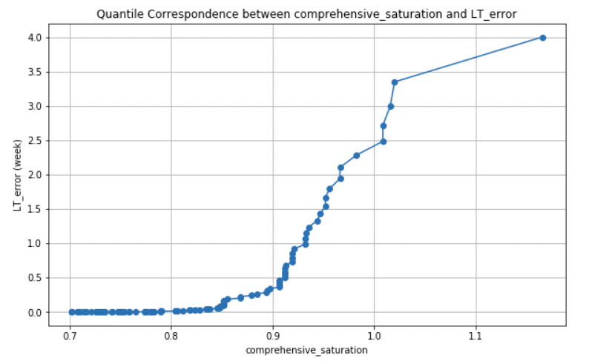
As shown in the figure, it displays the mapping relationship curve between saturation (horizontal axis) and LT error (vertical axis) obtained through numerical fitting. Among them, approximately 85% of the saturation corresponds to an LT error of 0.25 weeks, approximately 92% of the saturation corresponds to an LT error of 1 week, and 100% of the saturation corresponds to an LT error of 2.5 weeks. In the subsequent process, the Production LT error in the model will be estimated by using the future average saturation and the above mapping relationship curve.
  - QR LT mean & error
    - Remove outliers
    - Quantify LT volatility using input QR data

4.4 Output processing
The SEIO/MEIO outputs safety stock quantities at Material × Plant level with weekly granularity. Two ROP calculation types: ROP by unit and ROP by DOS is provided. The calculations of DOS differ by level:
- For FG × DC:
  - DOS = FUNC(Weekly safety stock quantity, Weekly demand forecast)
  - CDC & CDC-EAST forecast derives from weekly-split national forecast
  - RDC uses two statistical methods, the forecasts are derived from weekly-split national forecast and weekly deployment forecast respectively
- For RPM × Plant:
  - DOS = FUNC(Weekly safety stock quantity, Sum of related FGs' weekly demand forecasts at CDC level)
  - CDC forecast derives from weekly-split national forecast
The simulation module calculates unit-level ROP, where the cycle inventory is determined by DOS using the latest version of forecast data.

Simulation and Monitoring

5.1 Data structure and processing
Business data over simulation back-testing period
Sales | Actual sales mapped to back-test time period |  | Production Minimum Lot Size
LT | Stochastic LT |  | Uniform sampling between mean and mean+error.
LT | Fix LT |  | Fixed as mean.
Rolling ROP-Q inventory strategy
Safety stock of ROP | Granularity | Time windows of data over simulation reference period
Quarterly | FG × DC | Weekly sales: 2024.1 - current quarter end
Quarterly | FG × DC | Monthly national forecast: 2024.1 - current quarter end
Monthly | FG × DC | Weekly sales: 2024.1 - current month end
Monthly | FG × DC | Monthly national forecast: 2024.1 - current month end
Cycle inventory of ROP | Granularity | Direct available data
 | FG × CDC | Weekly national forecast: at current period
 | FG × RDC | Weekly forecast: at current period
Order batch size (Q) | Granularity | Direct available data
 | Material | Order batch size
Minimum Shipment Quantity  (MSQ) | Granularity | Direct available data
 | Material | Minimum shipment quantity

5.2 Framework design
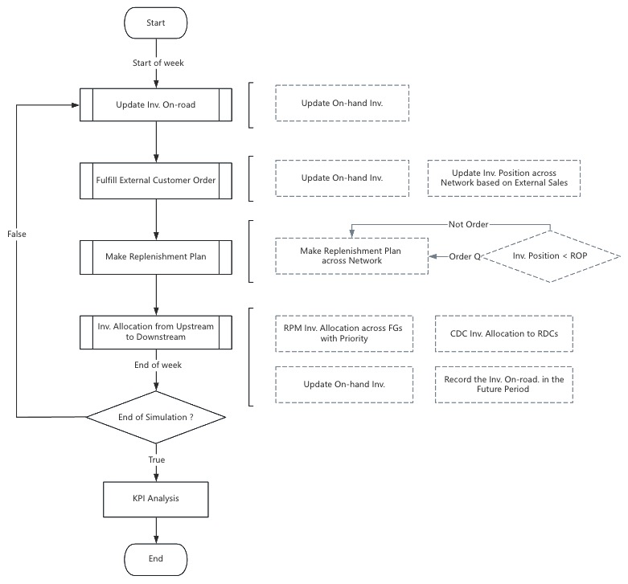

Figure 17. xxx

5.2.1 Key activities

5.2.1.1 External demand fulfillment
Fulfillment level: CDC × FG and RDC × FG level
Resource: On-hand inventory
Fulfillment rule: FIFO (First-In-First-Out)
- Historical backorders
- Current period orders
Key assumption at CDC level:
- Quta: 30% inventory for RDC; 70% inventory for CDC

5.2.1.2 Network material inventory allocation
Target level: Plant × Material with direct downstream
Execution basis: Requested replenishment plans
Sub-categories:
- Non-shared RPM / Supplier-RPM
  - Allocation rule: MIN (on-hand Inventory, replenishment plan)
- Shared RPM
If the sum of replenishment quantity is less than the on-hand inventory of RPM, the system will fulfill each order with its full requested quantity. Otherwise, the following allocation rules will be implemented to distribute the available RPM inventory among its corresponding FGs.
    - Proportional allocation rule & Production lot-size
      - Sort FG by category and requested quantity.
      - Fulfill the orders sequentially by batch until all FG demand is satisfied or RPM supply is exhausted.
- CDC Distribution:
The system maintains a predetermined inventory hold ratio to prevent over-allocation to RDCs. The CDC reserves a specific portion of on-hand inventory (set as 70% by default and adjustable), with the remainder available for RDC distribution. Allocation among RDCs is executed proportionally based on their replenishment planned quantities.

5.2.2 Simulation Period
Historical period: 6 months

5.2.3 Output KPIs
- Inventory-related metrics
  - Weekly average of inventory levels
  - Monthly average of end-of-month inventory levels
  - By ABC-class and FG: Historical distribution analysis of weekly inventory levels over simulation period
- Service level metrics
  - Weekly average cycle service level
  - Monthly average cycle service level
  - By FG: Average backorder time

5.3 Special case

5.3.1 Inventory Status Initialization for Material
- Target: All Material × Plant level
- Action: Direct initialization of inventory levels from inventory sizing module output inventory strategy

5.3.2 Existing Strategy Evaluation
Compare the calculated ROP-DOS against current values, flag bias exceeding ±20%, and output the results to Excel format.

